PRESS RELEASE

Having a handle on everything
The new modular generation of TIG welding torches from Fronius

The new Fronius welding torches for manual Tungsten Inert Gas welding (TIG) can be customized to suit the welder’s personal preferences as well as the welding task at hand. Their modular design offers a range of sustainable and cost-effective options.

Different requirements – one welding torch

Large or small handle? One control to set the amperage or an additional JobMaster display that can be used to access the pre-programmed settings? Different gas nozzles, different torch angles. “The perfect” TIG welding torch varies from application to application and every welder has their own preference. The modular design of the new TIG welding torches from Fronius allows you to cover all of these requirements without having to replace the entire torch.

The hosepack for manual TIG devices fits every torch body, which can likewise be individually adapted as well. There are different torch body lengths and angles to handle anything the application demands. Changing the torch body is easy and no tools are required with the Multilock System: the torch body is loosened from the hosepack by pressing and turning, and is secured by attaching and turning. For both gas-cooled and water-cooled systems with the torch empty function, it is even possible to safely change the torch body whilst the hosepack is still connected.

Different control options and ease of use

The ergonomic handles of the new TIG welding torches are available with three different interchangeable control elements: an Up-Down rocker switch, JobMaster display or rotatable potentiometer. When developing the new torches, a large amount of importance was also placed on ease of use: the handle is non-slip and contains soft components to take as much strain out of your work as possible. A ball joint between the hose and torch body ensures flexible handling. The torch body can also be turned endlessly. A further improvement for the welder is an LED light on the torch which illuminates the welding location before and after welding. Furthermore, depending on their preference, the user can choose between a standard and a smaller, size-optimized handle. This compact version is also available with different control options.

The modular design of the new TIG welding torches from Fronius is a sustainable solution: the welding torch does not have to be thrown away if requirements change or parts break. Instead, the individual modules are changed with ease. Changing components can take place directly on site and without the help of a service technician, saving resources, time and costs.

2,650 characters (including spaces)

[Navigation Title]
New modular TIG welding torch generation

[Display name: URL]
modular-tig-welding-torch

[Meta title]
New TIG welding torches from Fronius: modular design

[Meta description]
The modular torch body design offers a range of sustainable and cost-effective options, for example operating elements, handle sizes, torch body lengths and angles.

Captions:

Image 1: The new generation of TIG welding torches from Fronius is ergonomic and the soft grip components help to ward off fatigue during welding.

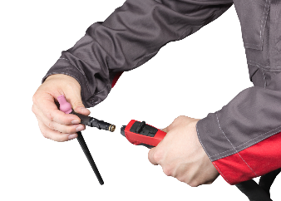
Image 2: The torch body can be changed easily, quickly and without the need for tools – ensuring high system availability.

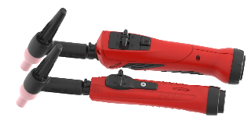
Image 3: The handle is available in two sizes.

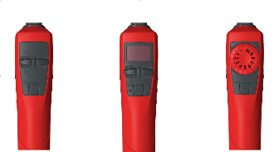
Image 4: Users can choose between three operating elements: Up-Down operation, JobMaster and potentiometer.

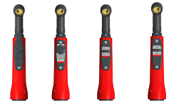
Image 5: The SmallHandle welding torches are also available with different control options (from left to right): long trigger, potentiometer, UpDown and standard.

Copyright to photos: Fronius International GmbH, reproduction free of charge

High-resolution images are available to download at the following link:
www.fronius.com/en/welding-technology/infocentre/press

Business Unit Perfect Welding
Fronius Perfect Welding is an innovation leader for arc welding and a global market leader for robot-assisted welding. As a systems provider, the Fronius Welding Automation division also implements customized automated complete welding solutions, for the construction of containers or offshore cladding for example. The range is rounded off by power sources for manual applications, welding accessories, and a broad spectrum of services. With more than 1000 sales partners worldwide, Fronius Perfect Welding has great customer proximity.

Fronius International GmbH
Fronius International GmbH is an Austrian company with headquarters in Pettenbach and other sites in Wels, Thalheim, Steinhaus and Sattledt. With 4,760 employees worldwide, the company is active in the fields of welding technology, photovoltaics and battery charging technology. 92% of its products are exported through 30 international Fronius subsidiaries and sales partners/representatives in over 60 countries. With its innovative products and services and 1,253 granted patents, Fronius is the global innovation leader.

For more information, please contact:
FRONIUS INDIA PVT. LTD; Geeta Kshirsagar
GAT no 312, Nanekarwadi, Chakan, Taluka- Khed District
Pune 410 501
Phone: +91 9607987766
E-Mail: marketing.india@fronius.com

Please send a specimen copy to our agency:
a1kommunikation Schweizer GmbH, Kirsten Ludwig,
Oberdorfstraße 31 A, D – 70794 Filderstadt, Germany
Phone: +49 (0)711 9454161-20
E-Mail: Kirsten.Ludwig@a1kommunikation.de

For more exciting updates, visit our blog at blog.perfectwelding.fronius.com and follow us on Facebook (froniuswelding), Twitter (froniusintweld), LinkedIn (perfect-welding), Instagram (froniuswelding) and YouTube (froniuswelding)!

