PRESS RELEASE

WireSense: The wire electrode that doubles as a sensor

WireSense is the assistance system from Fronius which makes robotic welding more efficient. The wire electrode is turned into a sensor that checks the component position before each weld. Manufacturing inaccuracies can be compensated for and perfect welding results achieved by reliably detecting actual sheet edge heights and positions. Rework and component rejects are largely eliminated, while additional optical measuring devices become unnecessary, resulting in significant time and cost savings.

Component deviations such as varying air gaps or clamping tolerances can cause welding problems. In the worst case scenario, these deviations result in a change in the welding position and cause a lack of fusion in the weld seam. For this reason, many manufacturing companies use optical measuring devices for robotic welding. Not only are they expensive but they also significantly restrict component accessibility, need regular cleaning and require additional calibration between the Tool Center Point (TCP) and the sensor. WireSense from Fronius offers an easier, more robust and precise alternative.

The science behind WireSense

WireSense technology does not require any additional sensor hardware components – instead the wire electrode is used as a sensor. The welding torch scans the component with a reversing wire movement and the welding system sends the height information and the edge position to the robot. For example, if a lap joint is being welded, the edge position can be precisely defined, and the system can react to any deviations. The robot adjusts the weld seam process based on an application-specific program.

By evaluating the height information, the robot can determine both the course of the edge and the actual edge height. It is also possible to determine the exact air gap between the sheets. Edges are detected from a height of 0.5 millimeters. WireSense can be used with steel, stainless steel, aluminum, and other alloys. It is with aluminum that WireSense truly comes into its own, as reflective surfaces are frequently a major obstacle for optical measuring devices.

Furthermore, optical sensors are usually installed on the robot as additional hardware where they become disruptive contours the robot arm. Depending on component accessibility, this makes the use of cameras or lasers problematic. The wire sensor does not impose any such restrictions.

An important step to adaptive robotic welding

WireSense delivers height information, which allows component contours and air gaps to be measured. During commissioning, welding parameters for different air gap sizes can be defined and saved. The WireSense assistance system therefore enables the robot to determine the actual component conditions in order to call up the suitable welding parameters. In anticipation of possible air gaps and other deviations that could lead to lack of fusion, without the use of sensors the welder often has to work at a reduced speed, in order to ensure a high weld seam quality. Thanks to the precise detection of such anomalies in advance, the robot can now join materials fully automatically at the optimal speed, which contributes to additional cycle time optimization.

In this way, the new WireSense technology ensures that welding is always performed at the exact weld seam position with optimized parameters. Final visual inspections, rework and component rejects can be significantly reduced resulting in time savings and serious cost reductions.

Requirements

WireSense can be used with any TPS/i welding system from Fronius that is configured for the use of the CMT welding process. The precise wire movement of the Robacta Drive CMT wirefeeder, which sits directly on the torch body, is crucially important. Retrofitting of existing welding systems is possible at any time due to their flexibility.

3,879 characters (including spaces)

[Navigation Title]
WireSense: Wire electrode that doubles as a sensor

[Display name: URL]
wiresense-technology

[Meta title]
Fronius WireSense: A step towards adaptive robotic welding

[Meta description]
WireSense increases the efficiency of robotic welding by using the wire electrode as a sensor, rendering additional optical measurement devices unnecessary.

Captions:

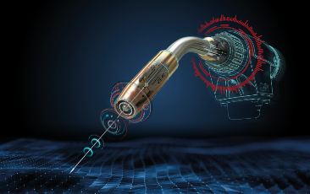
Image 1: The wire becomes a sensor with the new WireSense technology from Fronius.

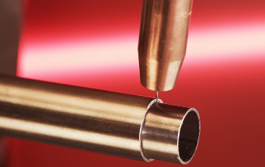
Image 2: With WireSense, the wire electrode scans the component and detects the edge position and height on both sheets and pipes.

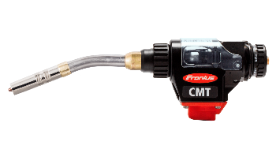
Image 3: The highly dynamic and precise wire movement of the Robacta Drive CMT drive unit makes it possible to scan the components using the wire electrode.

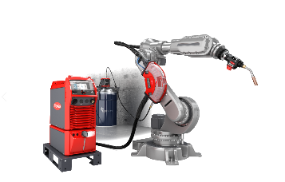
Image 4: WireSense can be used with every TPS/i welding system from Fronius that is equipped with hardware for the CMT welding process.

Copyright to photos: Fronius International GmbH, reproduction free of charge

High-resolution images are available to download at the following link:
www.fronius.com/en/welding-technology/infocentre/press

Business Unit Perfect Welding
Fronius Perfect Welding is the innovation leader for arc welding and is the global market leader for robot assisted welding. As system providers, Fronius Welding Automation also turns customer-specific automated complete welding solutions into reality in a number of areas, from container construction right up to cladding for the offshore sector. Power sources for manual applications, welding accessories and a wide range of services add to our portfolio. With more than 1,000 sales partners worldwide, Fronius Perfect Welding is never far away from our customers.

Fronius International GmbH
Fronius International GmbH is an Austrian company with headquarters in Pettenbach and other sites in Wels, Thalheim, Steinhaus and Sattledt. With 4,760 employees worldwide, the company is active in the fields of welding technology, photovoltaics and battery charging technology. 92% of its products are exported through 30 international Fronius subsidiaries and sales partners/representatives in over 60 countries. With its innovative products and services and 1,253 granted patents, Fronius is the global innovation leader.

For more information, please contact:
Fronius USA LLC, Ms. Welch Stephanie,
6797 Fronius Drive, 46368 Portage, IN
Tel: +1 (219) 734 5701, E-Mail: welch.stephanie@fronius.com

Please send an author's copy to our agent:
a1kommunikation Schweizer GmbH, FAO Kirsten Ludwig,
Oberdorfstraße 31 A, 70794 Filderstadt, Germany,
Tel.: +49 (0)711 9454161-20, e-mail: Kirsten.Ludwig@a1kommunikation.de

For more exciting updates, visit our blog at blog.perfectwelding.fronius.com and follow us on Facebook (froniuswelding), Twitter (froniusintweld), LinkedIn (perfect-welding), Instagram (froniuswelding) and YouTube (froniuswelding)!

